

American International University-Bangladesh (AIUB)
Department of Computer Science
Faculty of Science & Technology (FST)

PROJECT TITLE
Semester: Fall 25-26

Group: |  | Section:
SL | Student Name | Student ID
1
2
3
4
5

Table of Contents

1. Project Proposal xx
1.1 Background to the Problem xx
1.2 Selection of Process Model xx
2. Software Requirements Specification (SRS) / PRD xx
2.1 Scopes and Features xx
2.2 User Story Table xx
2.3 Requirements Traceability Matrix xx
2.3.1 Functional Requirements xx
2.3.2 Non-Functional Requirements xx
3. Software Design xx
3.1 System Deisgn xx
3.2 UI Deisgn using Figma xx
4. Git Workflow xx
5. Software Testing xx
6. Conclusion xx

1. PROJECT PROPOSAL

  - Background to the Problem

Background to the Problem Farmers in many regions face ongoing challenges due to unreliable electricity and the rising cost of fuel. To solve these problems, a new initiative called Famonergy Link encourages each farmer to install a solar power system on their land. This system allows them to generate their own electricity using sunlight for irrigation, farm machinery, and household needs.

By depending less on diesel generators and other fossil-fuel-based sources, farmers can cut costs and reduce pollution. Any unused electricity can also be stored for later use, ensuring a steady supply even during low-sunlight periods. If the solar panels produce more electricity than the farmer needs, the extra energy can be sent to the national power grid. By selling this surplus electricity, farmers can earn additional income, improving their financial stability while also supporting the nationʼs renewable energy production.

Famonergy Link not only promotes efficient energy use but also helps the country reduce its dependence on fossil fuels and move toward sustainable development. To manage the process easily, Famonergy Link provides an online platform where farmers can track how much electricity they have produced, consumed, stored, or sent to the grid. With their approval, the system can automatically transfer extra electricity to the national grid. Government authorities also benefit from this platform, as it provides real-time data for planning and monitoring national renewable energy progress. To encourage more participation, Famonergy Link includes a leaderboard highlighting top energy-producing farmers. National and personal production targets are set periodically, and farmers who meet or exceed these goals receive recognition and rewards.

This creates motivation, healthy competition, and supports a cleaner, more sustainable environment for future generations by lowering fossil fuel use and expanding renewable energy adoption.

  - Selection of Process Model
- Select a suitable Process Model for your project. Then, explain the process model with proper visualization. After that, you need to explain that ‘why did you choose this model’.

2. SOFTWARE REQUIREMENTS SPECIFICATIONS (SRS) / PRODUCT REQUIREMENTS DOCUMENT (PRD)

  - Scopes and Features

2.1.1 Scope 1: Solar Energy Generation and Management
This scope allows farmers to not only generate solar power but also to manage the power effectively. The platform provides real-time monitoring, allowing farmers to see how much energy their solar panels are generating and how much they are consuming. By comparing these values, farmers can optimize their energy usage, ensuring that they are maximizing the efficiency of their solar panels.
Additionally, the platform enables automatic energy storage management. When the solar panels generate more energy than is needed, the excess is stored in batteries. The platform will manage energy storage based on the farmer's consumption pattern and storage capacity, ensuring that energy is available when required, especially during cloudy or rainy days when solar production is low.
Another feature is the surplus energy transfer: the platform automatically sends the surplus energy to the national grid with the farmer’s approval. This not only contributes to the national renewable energy goal but also provides the farmer with compensation for the energy supplied to the grid.

2.1.2 Scope 2: Real-Time Data Monitoring and Rewards System
The platform offers real-time monitoring of energy generation and consumption, but it also features performance tracking in the form of a leaderboard. The leaderboard ranks farmers based on the amount of energy they produce, offering incentives for the top producers. This creates a sense of community and healthy competition among farmers to maximize their energy production.
National energy targets will be set periodically to encourage participation. Farmers who meet or exceed these targets will be recognized on the platform and may receive rewards such as subsidies, grants, or recognition at national events. This feature promotes sustainability, motivates farmers to adopt solar energy, and supports the growth of renewable energy production in the country.

2.1.3 Scope 3: Data Analytics and Reporting
This new scope would focus on providing farmers and stakeholders with in-depth analysis of energy data:
- Comprehensive Energy Reports: Generate detailed monthly, quarterly, and annual reports on energy production, consumption, storage, and grid transfer. These reports can be used for personal record-keeping or government audits, providing insights into energy trends and overall efficiency.
- Predictive Maintenance: Using data analytics, the system can predict when maintenance is due on solar panels or energy storage systems. This can be based on usage patterns, system performance, and external conditions like weather, ensuring that equipment is maintained before it fails.
- Impact Analysis: Government authorities and stakeholders could access detailed analytics to evaluate the environmental impact of the project, such as the amount of CO2 emissions reduced by the transition to solar energy in farming.
•

2.1.4 Scope 4: Financial Planning and Subsidy Integration
In addition to estimating the costs of transitioning to solar energy, here are new features for financial management:
- Real-Time Loan Tracking: Farmers can view real-time information about their solar energy loans, including loan repayment status, interest rates, and available subsidies. This feature could also send reminders for due payments or applications for financial assistance.
- Insurance Integration: Integrate a feature where farmers can purchase renewable energy-related insurance. This could cover risks like damage to solar panels or energy storage systems, providing financial security for farmers in case of system failures or natural disasters.
- Financial Education and Tools: Offer educational content, calculators, and financial planning tools to help farmers better understand the financial implications of switching to solar energy. This could include calculators for return on investment (ROI), payback periods, and savings from reduced electricity costs.
- Incentive Programs for Adoption: Integrate national and local government incentive programs that reward farmers for installing solar energy systems. The platform can automatically notify farmers of available subsidies, grants, and tax incentives based on their location and production.

2.2 User Story Table
User Type | Story
Farmer | As a farmer, I want to track my energy production, so I can see how much energy I am generating and determine if I have surplus to send to the grid.
Government Authority | As a government authority, I want to track the energy produced by farms in real-time so that I can make data-driven decisions on national energy policies.
Energy Grid Operator | As an energy grid operator, I want to validate and approve energy transfers from farms to the grid so that energy distribution is properly managed.
Financial Institution | As a financial institution, I want to track how much farmers earn from selling energy so I can manage subsidies and loan repayments effectively.

  - Requirements Traceability Matrix
Req ID | Requirement Description | Related Feature(s) | Actor
FR_01 | The system shall allow farmers to register using personal details. | Farmer Signup | Farmer
FR_02 | The system shall allow government authorities to register with their information. | Government Signup | Government Authority
FR_03 | The system shall allow users to log in using role-based authentication. | User Login | All
FR_04 | The system shall allow users to reset forgotten passwords securely. | Forgot Password | All
FR_05 | The system shall allow users to update profile information. | Profile Update | All
FR_06 | The system shall allow users to change their account password. | Change Password | All
FR_07 | The system shall display a dashboard with energy production data for farmers. | Farmer Dashboard | Farmer
FR_08 | The system shall allow farmers to search for energy data by time (daily/weekly/monthly). | Energy Data Search | Farmer
FR_09 | The system shall recommend suitable solar systems based on farm size and location. | Recommended Solar Systems | Farmer
FR_10 | The system shall show real-time energy production data on a map for farm monitoring. | Live Energy Tracking | Farmer
FR_11 | The system shall calculate and display the estimated energy savings. | Energy Savings Calculation | System
FR_12 | The system shall display energy production vs. consumption levels. | Energy Monitoring | Farmer
FR_13 | The system shall allow farmers to follow selected energy production reports. | Follow Reports | Farmer
FR_14 | The system shall send notifications for energy production milestones or anomalies. | Push Notifications | System
FR_15 | The system shall store and display farmers’ energy production history. | Energy History | Farmer
FR_16 | The system shall support Bangla and English language switching. | Language Toggle | All
FR_17 | The system shall display assigned solar energy production goals for government authorities. | Government Dashboard | Government Authority
FR_18 | The system shall allow government authorities to set national energy production targets. | Energy Goal Management | Government Authority
FR_19 | The system shall allow government authorities to monitor active energy production data. | Real-Time Monitoring | Government Authority
FR_20 | The system shall send periodic updates about energy production to government authorities. | Energy Updates | Government Authority
FR_21 | The system shall allow energy data to be manually updated by grid operators. | Grid Data Update | Grid Operator
FR_22 | The system shall display energy production data on a map during grid monitoring. | Energy Map | Grid Operator
FR_23 | The system shall generate energy production reports including total output and trends. | Energy Report Generation | Grid Operator
FR_24 | The system shall allow operators to view all active solar farms on a map. | Fleet Overview | Operator
FR_25 | The system shall allow operators to monitor energy production status in real-time. | Energy Status Monitor | Operator
FR_26 | The system shall allow operators to manage solar farm routes and energy generation locations. | Route Management | Operator
FR_27 | The system shall display analytics related to energy efficiency and anomalies. | Energy Analytics | Operator
FR_28 | The system shall allow exporting energy reports in CSV or PDF format. | Report Export | Operator
FR_29 | The system shall allow farmers and operators to view energy data in offline mode. | Offline Data Access | System
FR_30 | The system shall optimize GPS usage for tracking and reporting purposes. | Adaptive GPS | System
FR_31 | The system shall handle GPS or network failures gracefully. | Error Handling | System
FR_32 | The system shall restrict system access based on user roles (e.g., Farmer, Grid Operator). | Role-Based Access | System
FR_33 | The system shall ensure secure authentication using tokens or sessions. | Secure Authentication | System
FR_34 | The system shall provide localized Bangla and English content for users. | Localization | System

2.3.1 Functional Requirements
FARMERS:

• Login/Logout
Description: Farmers must be able to log into the system with their credentials (username and password) to access their account and use the platform. They should also be able to log out securely, terminating their session.

• Monitor Production
Description: Farmers can view real-time data on the solar power generated by their system. This includes metrics like energy produced in the current day, week, or month. They can also view trends and efficiency to optimize the system’s

• Monitor Consumption
Description: Farmers can track how much energy their farm is using for various activities such as irrigation, machinery, and lighting. This helps in managing energy consumption and ensuring energy-efficient practices.

• Manage Storage
Description: The system allows farmers to monitor the battery storage levels of their solar-powered system. They can view how much energy is stored and manage the use of stored energy during times of low solar generation.

• Transfer Energy
Description: Farmers can approve the transfer of surplus energy from their solar systems to the national grid. The system will show the amount of surplus energy available for transfer and request the farmer's approval before sending it to the grid. • Recalculation Based on Updated Production Data
Description: If energy production data changes (e.g., due to panel maintenance or weather conditions), the system will recalculate the farmer's available surplus energy. This will trigger a new calculation for how much energy can be sent to the grid.

• Track Earnings
Description: Farmers can track the earnings generated from selling surplus energy to the national grid. The system will show detailed records of energy sold, the amount paid, and the balance remaining in their accounts.

• Weather Alerts
Description: The system will notify farmers of any weather conditions (like storms, heavy rain, or cloud cover) that could affect solar energy production. These alerts help farmers plan energy management, ensuring they’re prepared for sudden weather changes.

Government Authorities:

•Login/Logout
Description: Government authorities need to securely log into the system to access data on energy production, grid contributions, and subsidies. They can log out after completing their tasks.

• View Reports
Description: Authorities can generate and view comprehensive reports on energy production, consumption, and grid transfers. This includes national energy statistics, trends, and farm-specific performance reports.

• View Environmental Impact
Description: Authorities can view the environmental impact of the project, including the total amount of carbon emissions reduced, the number of solar panels installed, and other sustainability metrics.

• Set Energy Goals
Description: Government authorities can set national or regional energy production targets for farmers. These targets motivate farmers and guide the policy direction for renewable energy initiatives.

• Manage Incentives
Description: Authorities can manage and distribute incentives such as subsidies, tax benefits, or grants to encourage more farmers to adopt solar energy. They can also track the effectiveness of these incentives.

Grid Operators

• Login/Logout
Description: Grid operators need to securely log in to the system to access energy transfer and grid monitoring features. They can log out once their tasks are complete.

• Energy Verification
Description: Grid operators verify the amount of energy transferred from farms to the national grid. This ensures the data is accurate and that farmers are credited correctly for their contributions.

• Energy Purchase
Description: Operators track the total energy purchased from farms and handle the financial transactions involved in paying farmers for the surplus energy supplied to the grid.

• Monitor Energy Transfer
Description: Grid operators monitor real-time energy transfers from farms to the grid. They ensure the process runs smoothly and track energy quantities to ensure the national grid is properly balanced.

Financial Institutions

• Login/Logout
Description: Financial institutions (banks, microfinance institutions) must log in to securely access farmers’ financial records, loan data, and payment details. They can log out after completing their tasks.

• Track Earnings
Description: Financial institutions track the income farmers receive from selling energy. They can view detailed data on energy sales and verify earnings to assist with loan repayments or subsidy management.

• Loan Tracking
Description: Financial institutions track the status of solar system loans provided to farmers, including repayment schedules, outstanding balances, and disbursement details. They ensure that loan repayments are being made

2.3.2 Non-Functional Requirements

1. Performance Requirements
- The Farmer Dashboard shall display real-time production, consumption, and storage data within 3 seconds.
- Daily, weekly, and monthly summaries shall load within 5 seconds.
- Weather alerts shall be delivered within 1 minute of receiving updates from external services.
- Government and Grid Operator dashboards shall refresh national and live grid data every 10 seconds.
- Financial dashboards shall generate earnings and loan summaries within 5 seconds.
- The system shall handle at least 100,000 farmers and 10,000 institutional users concurrently.

2. Reliability & Availability
- The system shall be available 24/7 with a minimum uptime of 99.5%.
- Energy production, transfer, and financial data shall not be lost during failures.
- Automatic backups shall occur every 24 hours.
- If a module fails (e.g., Reports), other modules (e.g., Farmer Dashboard, Grid Monitoring) shall continue functioning.

3. Security
- All users (Farmers, Authorities, Grid Operators, Financial Institutions) must log in using secure authentication.
- Role-based access control shall restrict features:
  - Farmers: production, consumption, storage, transfer approval
  - Government: reports, goals, incentives
  - Grid Operators: verification, monitoring, purchases
  - Financial Institutions: earnings and loans
- All financial and energy data shall be encrypted.
- Every energy transfer, approval, payment, and goal update shall be logged for audit.

4. Usability
- The system shall be simple enough for farmers with minimal technical knowledge.
- Each dashboard shall present key information in a single screen:
  - Farmer: production, consumption, storage, weather alerts
  - Government: national summary, targets, alerts
  - Grid Operator: live grid flow, incoming energy
  - Financial: earnings and loan overview
- No critical task (e.g., transfer approval, report generation) shall require more than 3 user actions.
- The platform shall support both English and Bangla.

5. Scalability
- The system shall scale to support nationwide adoption without redesign.
- It shall allow the future addition of:
  - AI-based energy forecasting
  - Advanced weather analytics
  - New financial partners and banks
  - More IoT devices per farm

6. Maintainability
- Each module (Farmer, Government, Grid, Financial) shall be independently maintainable.
- Updates to one module shall not disrupt others.
- Bug fixes and upgrades shall be deployable without system downtime.

7. Portability
- The system shall run on all modern web browsers.
- The Farmer module shall be optimized for mobile devices.
- The backend shall be cloud-deployable for nationwide access.

8. Data Integrity & Consistency
- Any change in production data shall automatically:
  - Update surplus energy
  - Trigger recalculation notices
  - Update earnings and reports
- Data shown across dashboards (Farmer, Government, Grid, Financial) shall remain consistent.
- Duplicate or conflicting energy records shall be prevented.

3. SOFTWARE DESIGN
3.1 System Design: Draw the system design for your project using Draw.io or LucidChart.

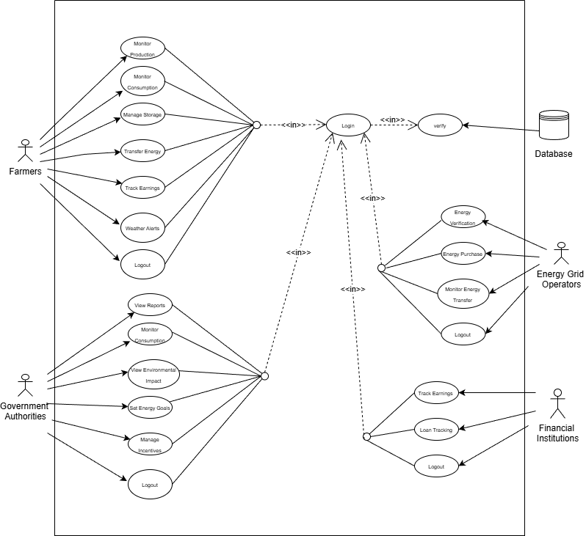
USE CASE:

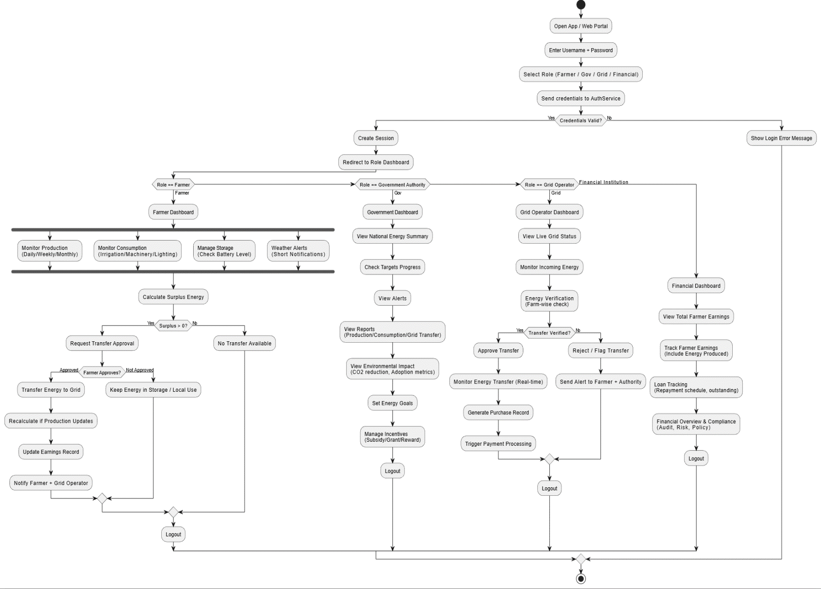

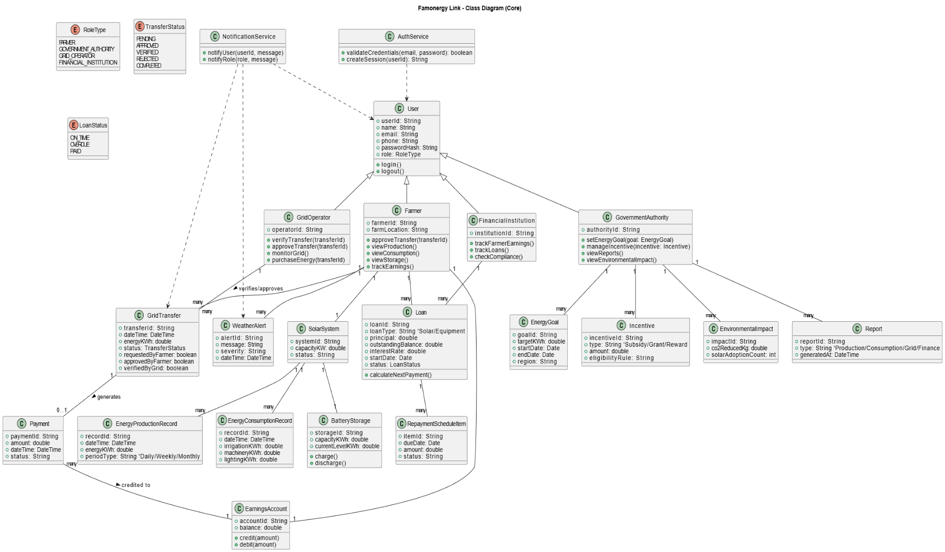

UI / Wireframe Design using Figma
- Build the wireframes directly from your SRS. Each functional requirement defined in the SRS should have a corresponding screen or component in the UI.
- Use the Trello user board (or equivalent task board) as a reference to decide which features and user flows need to be represented in the prototype.
- Create clickable wireframes that connect the main screens together, showing how a user will navigate through the system.
- Ensure the wireframe matches the actors, roles and functionalities described in the SRS and system design diagrams.
- Export the prototype and include screenshots or a link to your design as part of the report submission.

4. GIT WORKFLOW
- Create a central repository for the project on GitHub and set the master (or main) branch as the primary branch for integration.
- Each member should clone the repository and create their own feature branches for assigned tasks. Work on new features or fixes within these branches.
- Add files, stage them and commit changes with clear messages that describe the purpose of each update.
- Push commits from the feature branches to the remote repository so other members can see progress.
- Use pull to fetch and integrate changes from the remote repository into local copies, ensuring everyone stays updated.
- Merge feature branches into the master/main branch only after the work is tested and reviewed, resolving any conflicts that occur.
- Show evidence of collaboration by maintaining a clear commit history (using logs) with multiple commits, merges and contributions from all group members.
- Keep the repository organized with a clean history that tracks the project workflow from initialization to completion.

5. SOFTWARE TESTING

6.1 Functional Testing
Functional testing ensures that the system behaves according to the specified requirements. The following key modules were tested for functionality:
- Farmer Module:
  - Login/Logout: Verify that farmers can securely log in and log out of their accounts using the credentials.
  - Monitor Production: Test that farmers can view real-time data on solar power generation, track energy efficiency, and trends (daily, weekly, monthly).
  - Monitor Consumption: Ensure that farmers can accurately track energy usage for irrigation, machinery, and lighting.
  - Energy Transfer: Test that farmers can approve surplus energy transfer to the grid and receive notifications if recalculations are required.
- Government Authority Module:
  - Login/Logout: Verify that government authorities can access the platform securely.
  - View Reports: Ensure that government authorities can generate and view energy production, consumption, and grid transfer reports.
  - Set National Energy Goals: Test that authorities can set energy goals and track the progress of these goals.
- Grid Operator Module:
  - Energy Verification: Ensure that grid operators can verify energy supplied by farmers.
  - Energy Transfer Monitoring: Test real-time monitoring of energy transfers from farms to the national grid.
  - Energy Purchase & Payment Processing: Verify that grid operators can manage energy purchases and handle payment processing for farmers.
- Financial Institution Module:
  - Track Farmer Earnings: Test if financial institutions can view detailed earnings of farmers from energy production and track loan repayments.
  - Loan Tracking: Ensure financial institutions can monitor loan repayment statuses and outstanding balances.

6.2 Non-Functional Testing
Non-functional testing focuses on how the system performs under various conditions, including security, usability, and scalability.
- Usability Testing:
  - Test the ease of use of the platform, ensuring that users can navigate through the dashboards without confusion.
  - Verify that the platform’s layout is responsive and works well on mobile devices and desktops.
- Performance Testing:
  - Load Testing: Test the platform's ability to handle multiple users (farmers, grid operators, etc.) simultaneously without degradation in performance.
  - Stress Testing: Push the system to its limits (e.g., simulating a high number of simultaneous transactions) to see if the platform can recover gracefully.
  - Scalability Testing: Ensure the system can scale up as more farmers and users join the platform.
- Security Testing:
  - Authentication & Authorization: Ensure that each user role has the correct access permissions, and no unauthorized access is allowed.
  - Data Protection: Test encryption methods to protect user data and financial transactions, ensuring compliance with data privacy regulations.
  - Vulnerability Testing: Run vulnerability scans to detect and fix potential security holes (e.g., SQL injection, cross-site scripting).

6.3 Integration Testing
Integration testing ensures that the different modules of the platform work together seamlessly. Specific tests include:
- Farmer Data Integration: Ensure that the data entered by farmers, such as energy production, consumption, and earnings, integrates correctly with the financial and reporting modules.
- Grid and Energy Data Integration: Verify that grid operators can view energy data in real-time and that energy transfers from farms to the national grid are tracked properly.
- Loan and Payment Integration: Ensure that financial institutions can view and process loan payments correctly based on the earnings data from the platform.

6.4 System Testing
System testing verifies that the integrated system performs as expected. Tests include:
- End-to-End Functionality: Ensure that all workflows, from energy production to loan payments, are seamless from a user's perspective.
- Data Accuracy: Verify that energy production and consumption data, as well as loan repayment statuses, are accurately tracked and updated in real-time.
- User Interface Testing: Test the user interface to ensure that all elements (buttons, graphs, tables) function as expected and display accurate data.

6.5 Regression Testing
Regression testing ensures that updates or new changes to the platform do not negatively affect existing functionalities. The following areas are specifically tested during regression:
- Farmer Module Regression: Verify that any changes to the Farmer Module, such as new features (e.g., energy transfer approval, energy monitoring), do not disrupt core functionality like monitoring energy production, tracking consumption, or approving energy transfer to the grid.
- Government Authority Module Regression: Ensure that any new changes or updates, such as the addition of national energy goals or report generation enhancements, do not break existing features like viewing energy production data or setting goals for farmers.
- Grid Operator Module Regression: Test that updates to the grid operator functionality, such as the introduction of new real-time monitoring features or approval processes for energy transfers, do not interfere with previously functioning features like energy verification and purchase tracking.
- Financial Institution Module Regression: Ensure that modifications to the loan tracking, earnings calculation, or payment processing features do not affect the platform’s ability to track farmer earnings, manage loans, or process payments accurately.
- Cross-Module Regression: Verify that changes to one module (e.g., Financial Institution) do not negatively affect related modules (e.g., Farmer or Grid Operator modules) by ensuring seamless data flow between energy production, loan processing, and financial reporting.

- Prepare 3 test cases using a manual test case template which template taught you in the class. Suppose if you have total 4 members, then the total test cases will be 12.

6. CONCLUSION
- Write a conclusion within 180 to 200 words.

Instructions:
- Minimum of 3 members and Maximum of 5 members per group.
- Font: Times New Roman ; Size: 12; Justify the para [Ctrl + J].
- Delete the highlighted part after completing this project report.
- The completed report should be within the range of 40 to 50 pages.

- Submission: Bring a hard copy of this report [per group] on the project evaluation day. Also, you will need to upload the soft copy later.

